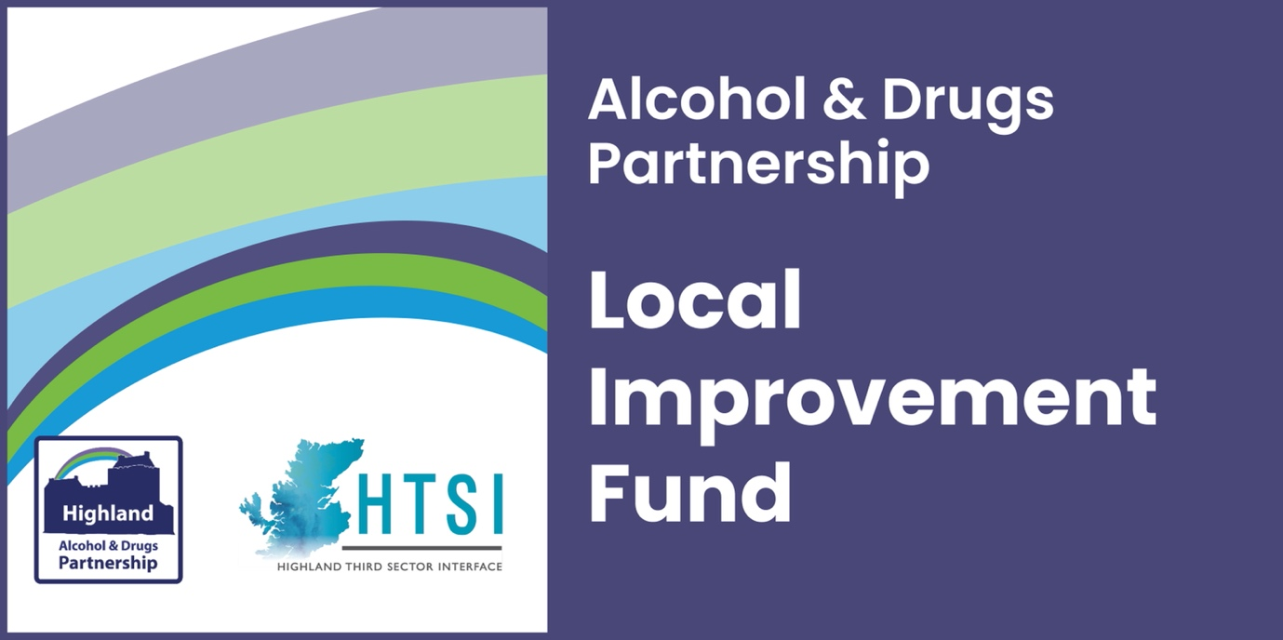

GUIDANCE DOCUMENT

Expressions of interest open on the 3 July and close 24 July 2023.
We encourage collaborative bids, where more than one organisation will be delivering the activity. It is important that one of the partners is selected to be the lead partner, responsible for authorising this expression of interest and being the main contact involved in discussions to develop a more detailed bid, if invited to do so.

The lead partner will also be responsible for submitting reports on request, with details of the expenditure and a description of the outcomes you have achieved.

EOIs must be submitted online using the form provided on the HTSI website, showing indicative costs for the proposed project and a summary of how you identified this need and developed your proposed project. You must meet the essential criteria to move to the next stage of the application process.

Essential criteria:
- In line with Highland ADP strategy
- Previous experience operating or delivering services in the area
- Previous experience working with vulnerable people
- People-led proposals (lived experience shaping the project)
- Clear outcomes for the participants (which will be measured)

Highland Alcohol & Drugs Partnership Strategic Outcomes:
- Reduce the number of people developing problematic use of substances by tackling the root causes of alcohol and drug-related harm at a local level.
- Reduce the number of people developing alcohol and drug-related harm by developing prevention and early intervention programmes through whole family approaches and family inclusive practice.
- Reduce harmful behaviours by offering targeted local support to individuals, families and groups.
- Improve access to support and treatment for individuals affected by alcohol and drug-related harm.
- Reduce stigma and improve reach and engagement with people affected by drug and alcohol problems, by promoting more inclusive, supportive communities.

You can read the HADP Strategy here https://www.highland-adp.org.uk/userfiles/file/hadp_general/HADP-Strategy-2020-2023-Nov-2020-FINAL.pdf.

How to complete the Expression of Interest (EOI):

Firstly, please read these instructions carefully before you begin putting together your EOI. Make sure you have given yourself time to prepare a draft before you start completing the online form. Aim to outline your plans clearly and evidence why they are necessary, explain why you are the best organisation to meet this need and deliver these aims. Also consider how you will account for the success of the project.
Identify someone that will read through the full and final version before sending it just in case it does not do justice to your organisation’s value, ideas, or your figures are entered inaccurately. Finally, include a contact name and email that will be checked regularly and remember to keep us informed of any personnel changes.
Each question below has a guide for what we want to see covered. If you have any questions or are uncertain, please contact funding@highlandtsi.org.uk.

LEAD ORGANISATION DETAILS – if you are submitting a collective bid, ie. on behalf of a group of organisations, you should agree who is the lead partner and add the details of the lead partner here.

- Organisation Name: The legal name of the organisation as shown on your governing document (as it appears on your constitution, articles, etc.).

- 3, 4 & 5. Main contact details: Please enter the details of the person we would be corresponding with the most, the person likely to have an operational responsibility for the work outlined in the application.

- 7, 8 & 9. Secondary contact details: These should be the contact details for a nominated member of your Board or Committee with strategic/overall responsibility for the work outlined in your application.

10. Are you collaborating with other organisation(s): please list the legal name of any organisations involved in this collective bid (as shown on their governing documents). If you have more than four partners, please contact us so we can advise.

11. Describe your organisation’s previous experience working with vulnerable groups:
The lead partner should describe their relevant experience working with vulnerable groups and of your partners if applicable. Include brief descriptions of previous projects, who you delivered services/activities for and how you managed to ensure the safety of everyone involved, handled sensitive information and anything you learned from that experience, which has affected your current practice.

12. Give brief details of the existing connections your organisation has within the community that will support your proposals: We want to see evidence that you are working well with others in your area. We would encourage you to think about how you reach out, how people with lived experience are involved in your work and we want to see evidence that you do not work in isolation from the other organisations around you.
13. Project Name: Please provide the name of your activity or project - something that will easily identify it within the application process and will continue to be used for reporting purposes.
14. Describe the activity you want to fund: Ideally, we are looking for your description to be focused and broken down into clearly defined sections. Your maximum word count is 500 words for this question. Make sure you cover:
What you will do: What is it you are proposing to deliver, for example, providing a youth hub in the local area with staff facilitating group activities and offering one to one support.
Who your activity will be for: Are you looking to support a particular age group or gender? Are there characteristics or a geographical boundary that you need to tell us about?
How you will do it: This is where you need to be specific about the sorts of activities and resources you are going to deliver or need. For example, we will provide weekly peer support groups facilitated by a trained support worker.
15. Name one or more outcomes you hope your project will help participants to achieve:
Please use concise, active language to describe the changes you hope participants will experience, such as:
- improve confidence/resilience
- reduce harmful behaviour
- increase healthy choices
Remember, an outcome is about the change you want to bring about, so it will usually include change words, as in the above examples. There is no need to include specifics about who or how, as this should be covered by your answer to Q14.
It is important to consider how you would measure success against these outcomes and only include them if you can track progress against them, eg. by capturing feedback, measuring wellbeing/confidence, or observing changes in behaviour. There is no need to provide more than two outcomes, possibly three. A longer list of outcomes is not more convincing or reassuring than one clearly defined and measurable outcome.
If you are at all unsure if you have correctly described your outcome(s), please contact us before you submit the form, so that we can help. This is one of the essential criteria for passing this first stage of the application.
16. Describe how this activity meets one or more of the HADP Strategic Outcomes: The overarching purpose of the funding is to enable activities and services to develop in ways that prevent and reduce alcohol and drug-related harm and associated deaths. The proposed activity should align with at least one of the Highland ADP’s Strategic Outcomes, listed on page one and this is essential to pass the first stage of the application process.
Please select one or more and describe how you believe you can have some impact on this outcome, and how you will evidence this, as it will be expected should your application be successful.
17. Describe your plans for monitoring and evaluating the project: If you have your own methods of monitoring and evaluating your project, please include what you will monitor and/or measure and how often, e.g. conduct wellbeing surveys before and after people participate in the programme. If you would like to know more about the Short WEMWBS tool and health questions, please contact us to discuss how you could build that into your proposals.
18. Total cost of activity: Please estimate the cost of all required resources, including equipment, staff salary and on-costs including travel and training. You can only insert numerical data into this section, so we are not looking for a breakdown of costs at this stage.
19. Amount requested from Local Improvement Fund: The amount requested in this application should be the total costs (both capital and revenue), less any match or other funding. Deduct any reserves you can contribute, or match funding awarded or anticipated (see below) from your total costs. This will leave the amount of funding you are requesting from the fund.
20. Match funding (if applicable): Please add the amount of funding you have received (or expect to receive) that will offset some of the costs in this proposal.
Although match funding is not required, this is welcome if appropriate for your proposal.
If you have funding which is anticipated to come in (i.e. from trading) or an award that is confirmed or applied for, then please add these details as appropriate.
21. Describe how you have involved (or will involve) those with living/lived experience in developing this proposal: It is essential that these grants fund projects that involve people who understand the current issues in Highland and the complexity of the root causes. We would expect you to provide some evidence that involvement of those with living/lived experience is the reason you believe your community needs this service, project or activity.
22. How will you ensure they are meaningfully involved in future project development and delivery: It is essential that your proposals outline how you ensure that the experiences of those with living/lived experience are reflected in the design and delivery of your project, to ensure its success in achieving change for those people affected (either directly or indirectly) by substance misuse.
Signed on behalf of [organisation]: Please add your lead organisation’s name here to certify that you are signing on their behalf. Sign your name on the next line and select today’s date. Please add the name and job title (or designation) of the person who signed the form.
Please contact Marion MacNeil at funding@highlandtsi.org.uk if you have any queries.

