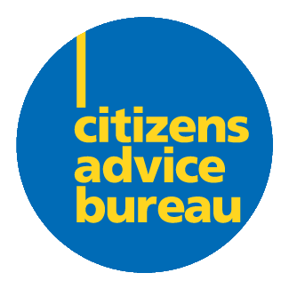
Are you interested in being a
CAB Board Member?
Ross & Cromarty CAB

Summary of role
- As a Board Member you are responsible for the strategic management of the Bureau. Each CAB is a separate registered Charity and for your local bureau to be effective a wide range of experience is required. We welcome Board Members who are enthusiastic about helping their community, even if they don’t feel they have specific professional skills.
What might you be doing?
- Attend Board Meetings regularly (approximately 6 each year)
- Take an active part in the discussions at the meetings
- Take an interest in the work of the bureau
- You might have a specific skill you can bring to the board eg financial management
- Help set policies, local objective and bureau projects
- Provide enthusiastic support for bureau volunteers and staff locally

Does this sound like you?
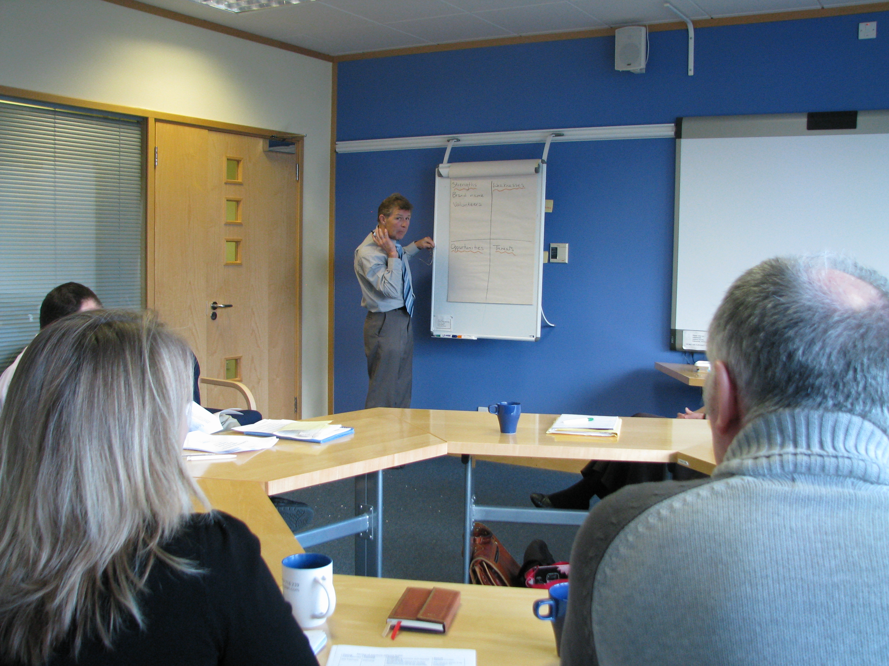
            - Aware of local issues
            - Committed to the Aims and Principles of the Service
            - Able to think creatively and exercise good, independent judgement
            - Work effectively as a member of a team
            - Happy to improve awareness of Equality and Diversity issues
            - Able to understand and accept the responsibility of being a trustee and employer
            - May have a specific organisational skill.

