


On the 12th June 2025, more than 90 of our members attended our Annual conference at UHI where we
- Heard from Dr Luis Felipe Yanes of the Scottish Human Rights Commission
- Took part in a variety of workshops
- Received updates on Martyn’s law
- And enjoyed a panel discussion about employability and workforce in the Highlands.
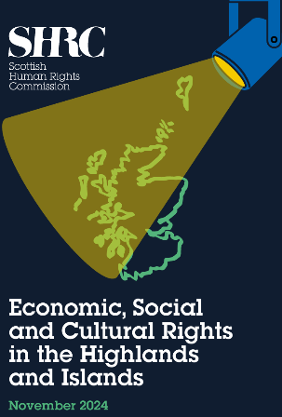
‘Economic, Social and Cultural Rights in the Highlands and Islands’
Luis Yanes the author of this powerful research report published in November 2024 opened the day and explored how communities across the region experience rights related to housing, health, education, and more — and examined how geography, inequality, and community strength shape those experiences.
Luis presented key findings and recommendations from the report, and offered a unique opportunity to explore the implications for policy and practice across sectors. He left enough time for some questions but we were lucky to have him join us for most of the day, so he was kept busy with lots of people keen to speak to him long after his presentation was finished.

The day had three different time slots for workshops from a variety of different presenters.

We had ‘What’s Out There for You? Support and Resources for Enterprising Third Sector’ ran by James Turner, the Head of Strengthening Communities for HIE. He discussed the range of support available from both HIE and other partners to help enterprising Third Sector Organisations in Highland thrive and also looking ahead to the future of the development of social enterprise and communities.


And also Marta Lester-Crinn the Deputy CEO of Evaluation Support Scotland (ESS) ran a workshop about ‘The Joy of Clear Outcomes’ She covered the importance of evaluation on how you measure and report on what impact you have made, as well as using it as a tool to learn what works. And she was able to simplify and clarify how to write clear outcomes to enable this.

Fiona Richardson, a Community Development Manager at Highland Council led a session on Place Planning. Although most were familiar with the concept, she gave us the latest update on the situation in the Highlands and its effect on the Third Sector. It included current developments, emerging priorities and what’s coming next.


Brendan Dougan from the Scottish Drugs Forum spoke of ‘Pathways With Purpose: Embedded Lived and Living Experience in the Workforce’ He explained the existing pathway in the Highlands which supports people with lived and living experience which help the move into meaningful employment and how this approach is shaping workforce development, service delivery and wider system change.

Chris Leslie from the Scottish Book Trust joined us for a workshop on Storytelling for the third sector. This engaging, hands-on session helped people to think differently about their organisation’s narrative. Chris explored fun, thoughtful ways to uncover, shape and share the story whether it be to funders, public or their own team.
We kept Martha from ESS busy and she ran another workshop on the ‘Five principles to ensure good evaluation’ ensuring that evauation should be about what matters, fit the way you do your work, involve the people you support, be used by you and be communicated well. Her interactive session introduced the principles and allowed the sharing of ideas and the swapping of useful tips.


Luthien Lark, the Volunteer Academy Team Leader at HTSI ran a workshop on Volunteer Recruitment and shared practical tips and strategies for recruiting, engaging, and retaining volunteers in today’s evolving landscape.

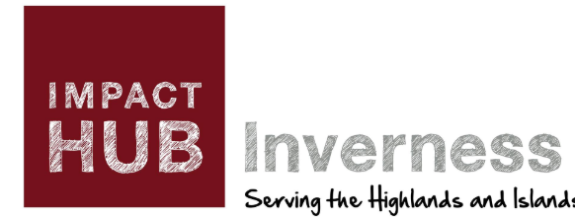
And finally, we had Karen Maclean-Yuille, Clarrie Murdoch and Claire McLaughlin join us from Impact Hub Scotland to give us their top tips for Procurement. They overviewed the support available from Just Enterprise for funded business support for social enterprises and third sector organisations, from business planning and governance to marketing, finance, and income generation. The session shared lots of practical tips, useful contacts, and clear signposting for further support.

And in between these was a brief on the new Terrorism (Protection of Premises) Act 2025 which has recently come into law. It is much more commonly known as Martyn’s Law named after one of the victims of the Manchester Arena Bombing. Kirsty Harding gave an overview of this new law with a focus on what it might mean for the third sector and what people should be starting to think and act upon with the enforcement due in 2 years’ time. The subject was then opened to the floor for questions to both PC Lisa Campbell, a Counter Terrorism Officer from Police Scotland and Mike Colliar, Group Commander from the Scottish Fire and Rescue Service.

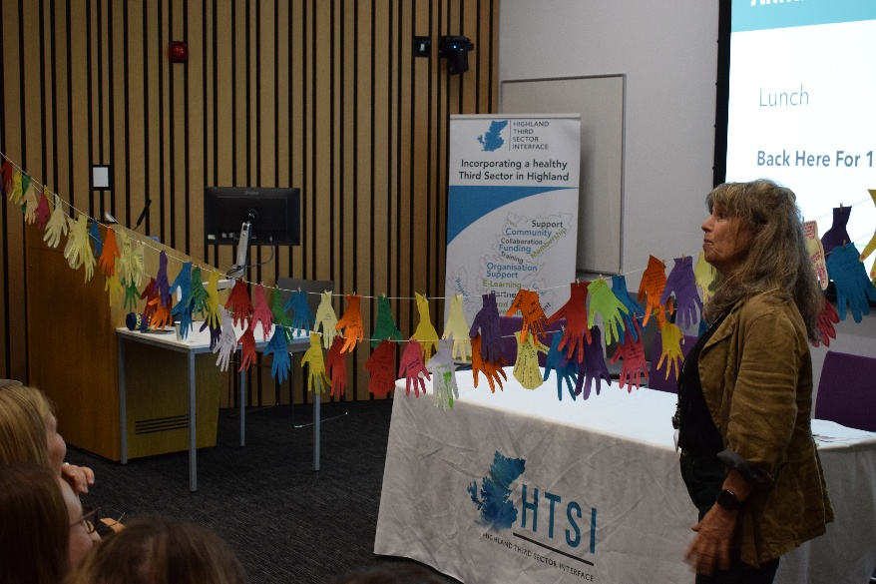
After a break for lunch which allowed for lots of networking, catching up with friends and making new ones it was back into the auditorium for a post lunch energiser run by local artist and UHI lecturer Rosie Newman. The results were a beautiful line of colourful paper hands, with a wee bit of ink left on some of the real hands!

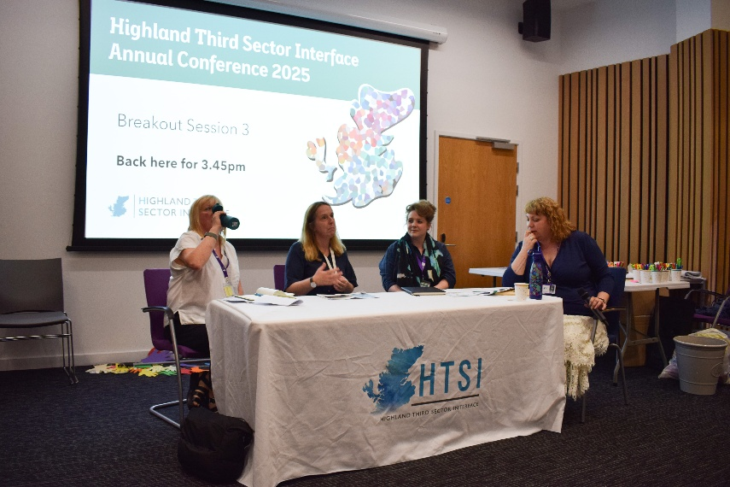
The final event of the day was a panel discussion on employability and workforce futures in the Highlands. The speakers came from a wide range of industries with Alli Vass, representing the Inverness and Cromarty Firth Green Freeport, Samantha Fraser from Orbex, an orbital launch services company based in Moray and Gwen Harrison, Independent Sector Lead for Care Homes in Highland. Each gave us a short presentation before it was opened to the floor for questions. All three industries face challenges of very different natures and it was a great insight into each of the different worlds in which they work.

The day finished with some closing words from our Chief Officer Mhairi Wylie before time for some mocktails. Overall, the event was a great success, providing valuable networking opportunities, lots of learning and the chance to catch up with colleagues and friends.

