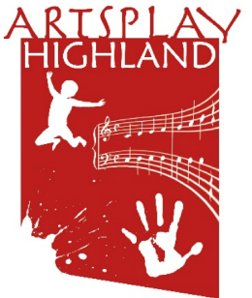
Artsplay Highland is a charitable organisation in the Highlands.
Since 2003 we have provided specialist early years music and arts activities to nurseries and primary school infant classes. We are passionate about providing opportunities to young children (3-7 years approx.) to experience and enjoy music and the arts. We know the importance of young children having access to music and arts and the significant benefit this has on early years development both socially and educationally.

In addition to providing sessions for children, we also support families, nursery staff and school staff with training and support so that they can continue to share the joy and benefits of music and arts activities with the young children in their care.
About us
Artsplay Highland are seeking new Board members
Why join now: Artsplay is currently at a crucial point in the organisation’s development. There are opportunities and scope to make the organisation more resilient by expanding into new activities, including revenue generating services, whilst continuing to expand the free services we currently provide.

We would like to recruit new members to the board to provide new insights, skills, experience, and connections to help us to move in exciting new directions.

We are a young, vibrant organisation committed to making sure young children have access to music and the arts.

About being a board member: Board members will play a critical role in the future development and governance of Artsplay Highland. As a Board Member you will be responsible for the strategic management of Artsplay Highland. You can expect to attend around 6 board meetings per year, taking an active part in these meetings and providing direction and advice to staff. Board meetings generally take place either online or face-to-face in the Inverness area.
Artsplay are seeking to appoint dynamic individuals from within the social enterprise, business, education, or creative sectors, with a passion for music and the arts and/or early learning. We are looking for individuals who have experience in HR, project development and income generation. This position of board members is on a voluntary basis,
There has never been a more exciting time to join the board as we start to develop and grow.
Further information: If you feel you can contribute your skills, experience, and have some time, then we would like to hear from you. Expressions of interest can be made by e-mailing: artsplayhighlandrecruitment@gmail.com
We look forward to hearing from you!

