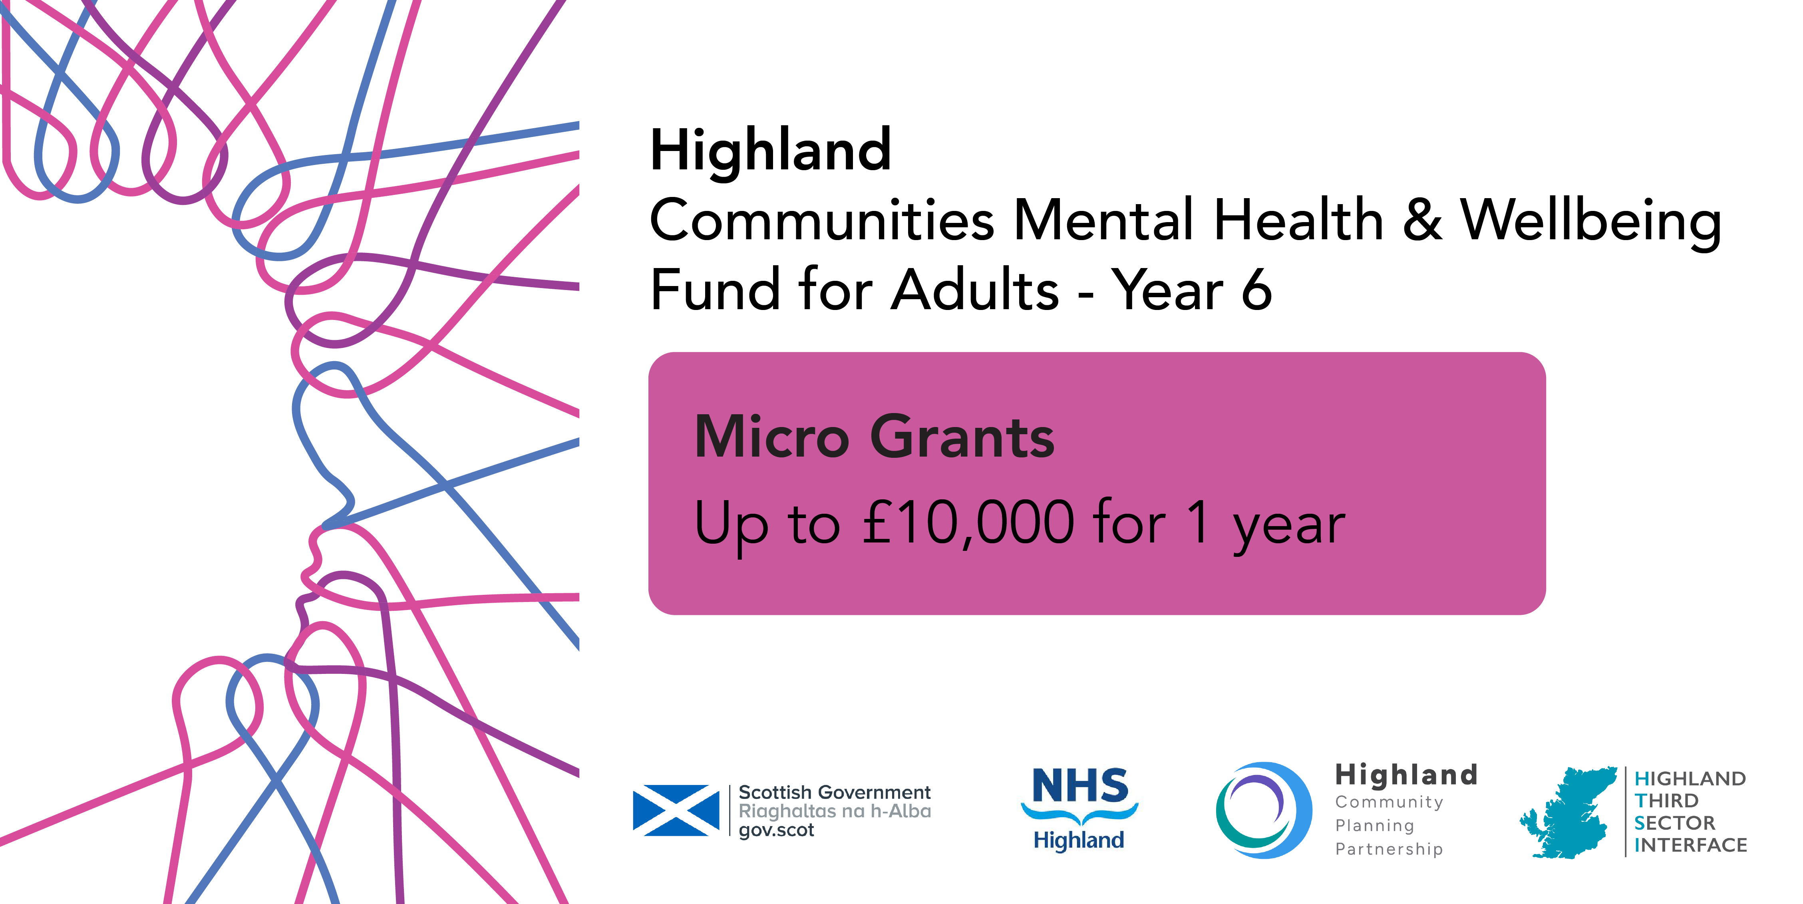

Micro Grants Application £10,000 or less
(Progress may be saved and completed later, select 'save' instead of 'submit'.) Please read through the guidance document carefully before completing this form. Your application should be submitted by MIDDAY on Thursday 13 August

SAMPLE APPLICATION – PLEASE SUBMIT APPLICATION ONLINE

- Do you have a bank account registered in your organisation’s name?*
Yes
No
- Do you have a Fair Work First policy statement?*
Yes
No
We do not have any employees
- Have you applied/do you intend to apply to any other TSIs for Communities Mental Health & Wellbeing for Adults funding?
Yes (If yes, select local authority area from the provided list)
No
Not Sure

Tell us about your organisation
- Name of organisation

- Main Contact
First Name:
Last Name:

- Job Title/designation

- Email Address

- Phone No:

- Secondary Contact
Last Name:
First Name:
- Job title/designation

- Email

- Phone Number

- Briefly tell us about your organisation (50 words)

This is not where you describe your project plans

Tell us about your project
- Name of project and project postcode:

- Please tick one of the following types of initiatives which best describes your project

- Befriending
- Peer support
- Counselling
- Therapeutic
- Mentoring
- Financial inclusion/cost of living
- One to one
- Group activity
- Equipment
- Food
- Nature
- Social
- Arts and crafts
- Maintenance/repair
- Sport or physical activity
- Culture

- Please estimate the number of volunteers involved in delivering the project

- Please describe the project including its key aims and activities and how this supports mental health and wellbeing. (max 100 words)

- Is your project for the general population (general); open to all but with a focus on particular target groups (targeted); or, aimed only at particular target groups (restricted)?
- General
- Targeted
- Restricted
- If your project is targeting specific groups of people, which groups of people are you seeking to reach? (Select no more than three)
- Women (particularly women affected by gender-based violence)
- People with a long-term health condition or disability
- People from a minority ethnic background
- Refugees and those with no recourse to public funds
- People facing socio-economic disadvantage
- People experiencing severe and multiple disadvantage
- People with diagnosed mental illness
- People affected by psychological trauma (including adverse childhood experiences)
- People who have experienced bereavement or loss
- People disadvantaged by geographical location (particularly remote and rural areas)
- People with neurological conditions or learning disabilities, and from neurodiverse communities
- Older people (aged 50 and above)
- Young people aged 16-24
- Lesbian, Gay, Bisexual, Transgender and Intersex (LGBTI) communities
- Other (please describe)

- Cost of Living - the following family types are considered to be most at risk of poverty. Please select any or all who are highly likely to engage with this project.
- Lone parents
- Families with a disabled family member
- Families with 3+ Children
- Minority ethnic families
- Families where the youngest children are under 1 year old
- Mothers aged less than 25
- National/Local Priorities – please tick any or all of the following priorities your project will contribute to:
- Suicide prevention
- Social Isolation/loneliness
- Addressing poverty and inequality
- Other (select from Local Priorities List below)
  - Supporting Unpaid carers

Tell us about your finances
- Please select the category which describes the income of your organisation:
- Organisation with income up to £5,000
- Organisation with income up to £10,000
- Organisation with income up to £25,000
- Organisation with income between £25,000 and £100,000
- Organisation with income between £100,000 and £500,000
- Organisation with income between £500,000 and £1 million per annum
- Organisation with income over £1 million per annum
- Have you received a grant from the Communities Mental Health & Wellbeing Fund from HTSI before? Yes/No
- Is your application for a new project or for a continuation/expansion of an existing project? (Select one)
- New project
- Existing project (funded through the Communities Fund)
- Existing project (New to Communities Fund but funded previously through another funding organisation)
[
Costs breakdown for the project:

- Projected REVENUE expenditure for the activity/service:
Revenue expenditure item | £
Total revenue costs

- Projected CAPITAL expenditure for the activity/service:
Capital Expenditure item | £
Total capital costs

- Total projects costs (rounded with no currency symbols or commas)
£
Combined revenue and capital costs

- Match funding if applicable:
£ | Funded by? | Confirmed? Yes/No

- Amount requested:
£
Amount requested from us:

- Please provide one or more outcomes that describe the changes you hope participants will achieve through involvement with the above activity: (20 words max per outcome)
Brief description of outcome only
1
2
3
4

Tell us more about your organisation

- What is the legal structure of your organisation?
- Scottish Charitable Incorporated Organisations (SCIO)
- Companies Limited by Guarantee
- Trusts
- Not-for-profit company or asset locked company or Community Interest Companies (CIC)
- Cooperative and Community Benefit Societies
- Community councils
- Parent councils

- If you are a registered charity and/or company, please tell us your registration number(s):
- Charity Number
- Company Number

- Please provide your organisation’s address and contact details:
- Full address
- Postcode
- Website/Social media URL
- Office/admin email

- How many people are on the board or committee that runs your organisation?

- Please complete the following for the period ending 31 March 2025 (for your whole organisation, not the department related to this application). You will be asked to attach a copy of your latest accounts (or an alternative if you are a new organisation) at the end of the form.
2024/25 | £
Income
Expenditure
Surplus or deficit at year end
Total savings/reserves at year end
Total unrestricted reserves at year end

If your accounts cover a different period, explain below. (20 words max)
- In which locality do you plan to focus your work?
- Badenoch & Strathspey
- Caithness
- Easter Ross
- Highland-wide
- Inverness-shire
- Lochaber
- Mid-Ross
- Nairnshire
- Skye & Lochalsh
- Sutherland
- Wester Ross

- Is there a specific geographic community or neighbourhood you will focus on within the above locality? free text

Tell us more about your project proposal

- What dates will you start and finish your activity? We encourage you to get started as soon as possible, preferably before end 2026 and 1 April 2027 at the latest. We expect most projects to conclude within 12 months or less.
Start Date
End Date

Tell us more about the activity
- Describe how you identified a need for this activity? We particularly want to know how people you hope will benefit from this activity have been part of the process: (200 words)

- Give examples of additional measures you will take to ensure you can break down the barriers to *inclusion to reach your target group(s): 200 words

- Please give examples of how you plan to measure progress against the intended outcomes for participants in this project, to help you demonstrate the impact. 100 words

- Tell us how you are working with other organisations, or stakeholders in your area: 150 words

- Please confirm you have the authority for submitting this application and the potential undertaking it represents.
Name
Position
Signature

Please attach a copy of your latest verified accounts, as required by your governance structure, or a financial statement if you don't yet have one year's accounts.
Before adding your application into the online application portal, please check the spelling, calculations etc. for errors and preferably ask someone to sense-check the content in the whole application.
After adding this to the online application form, but before clicking submit, we recommend you double check the formatting and look for typos, accuracy and clarity.

