Volunteer role |  |  | Retail Assistant
 | 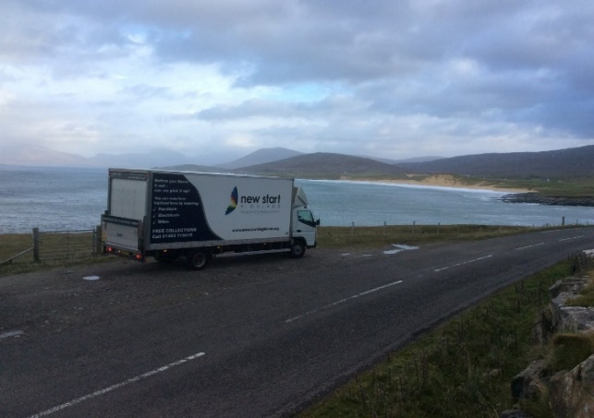
Location |  | Based at Carsegate Road North, Inverness
Time commitment |  | Minimum half a day a week.
Description of duties |  | We need your help to reduce homelessness and landfill. Come and join our retail team who are the friendly faces around our two Inverness outlets. A typical day in the shop could include:  - Making sure all items in the shop look spotless  - Sorting through and organising stock  - Dealing with customers’ queries in a friendly and efficient way  - Handling cash and working on the till
Person spec: |  | Must have good communication and teamwork skills with the ability to carry out instructions and be courteous with the general public. Representing New Start’s core values at all times.
Support and benefits |  | Induction followed by introduction to Retail department. Thereafter ongoing work-based training and opportunities to join certificated courses in Health and Safety, Manual Handling and First Aid.  All expenses paid.  Volunteers will be managed and trained by Connor Macleod and Violet Reid.

