## C:\Users\JBird\Downloads\Untitled design (17).png

## Peer Recovery Coordinator – Application Pack – Mid & East Ross

**Hours:** 16 hours per week

**Salary:** £28,101 full time equivalent (£12,846 pro-rata: £15.44 per hour)

**Pension:** SPIRIT Advocacy operates under the NEST pension scheme. 5% contributions are made to your nest pension after 3 months of probation. The employee contribution to the pension is 3%.

**Holidays:** The Annual Leave entitlement per year is 5 weeks plus public holidays (pro rata)

**Contract:** 9 months

**Location:** Hybrid – community-based across Mid and East Ross, with some home working supported by provision of equipment (e.g. laptop and phone) and occasional travel to Inverness for meetings or training

**Line Manager:** Chief Executive Officer

**Flexibility And Working Conditions**

This role is designed to be flexible. Hours can be arranged to suit the needs and wellbeing of the postholder and can accommodate caring responsibilities or phased working patterns.

**About the Pathways to Recovery Project**

Pathways to Recovery is a collaborative initiative between Spirit Advocacy, Connecting Carers, and NHS Highland. It will support people 18 and over who have lived experience and/or caring for someone who has lived experience in Mid and East Ross with their mental health and well-being by providing peer-led, relational support grounded in lived experience.

Peer Navigators work alongside individuals to help them make sense of their experiences, build confidence in navigating services, and feel empowered in their recovery. The project aims to:

* Improve access to compassionate, person-led support
* Reduce feelings of isolation, distress or being 'stuck'
* Strengthen collaboration between communities, services, and support networks
* Build local capacity through values-based training and partnership working

We are recruiting a Peer Recovery Co-ordinator to lead and support the development of this project. The Co-ordinator will ensure the project’s values and aims are realised across both areas by supporting two Peer Navigators, maintaining key partnerships, and embedding reflective practice.

**About Spirit Advocacy**

Spirit Advocacy is a lived-experience-led organisation that exists to amplify the voice of those with lived experience of mental ill health, neurodiversity, learning disability, and related issues. We believe in compassionate and relational support models that challenge stigma and promote recovery, rights, and inclusion.

Our work is grounded in CRIES values framework that reflects the character and culture of our work

* Compassionate
* Respectful
* Inclusive
* Empowering
* Supportive.

Spirit Advocacy operates across Highland through regionally based collective advocacy services such as HUG (Action for Mental Health), People First Highland, and localised Experience Matters Advisory Panels.

This new Pathways to Recovery Project is funded through the Scottish Government’s Community Mental Health and Wellbeing Fund and delivered in collaboration with Connecting Carers and NHS Highland.

To find out more about Spirit Advocacy, visit **www.spiritadvocacy.org.uk**.

**About the role**

The Peer Recovery Coordinator leads the delivery of peer-led support across Mid and East Ross, ensuring safe, trauma-informed, and relational practice across the team. They will work closely with Peer Recovery Navigators, support reflective practice, and maintain strong partnerships with Connecting Carers, NHS Highland, and third sector organisations.

This is a leadership role rooted in values-based supervision, lived experience, and collaboration. The Coordinator ensures that participants feel supported, peer staff feel valued, and the overall project is responsive, safe, and effective.

**Key Responsibilities:**

**1. Leadership and Supervision**

* Recovery Navigators
* Model relational, trauma-informed approaches in line with the CRIES values
* Provide regular supervision and reflective practice support to peer staff with boundaries, safeguarding, wellbeing and development needs

**2. Project Delivery and Coordination**

* Co-ordinate day-to-day project delivery across Mid and East Ross
* Maintain tracking systems, referral pathways, and project data
* Promote awareness of Spirit Advocacy’s membership and advocacy opportunities
* Ensure accurate, confidential records are kept in line with data protection standards

**3. Partnership Working and Collaboration**

* Develop strong working relationships with project partners (e.g. Connecting Carers, NHS Highland)
* Represent Spirit Advocacy in strategic forums, partnerships, and networks
* Promote peer support and recovery-orientated care through collaboration and advocacy

**4. Learning, Impact and Evaluation**

* Lead on evaluation, feedback, and reporting in collaboration with Spirit Advocacy colleagues
* Facilitate group reflection, learning, and values-based team development
* Adapt delivery to meet emerging needs and maintain participant-centred support

**Person Specification**

**Essential Experience and Knowledge**

* Lived experience of mental ill health, neurodiversity, or caregiving
* Strong understanding of peer support and relational models of care
* Awareness of trauma-informed practice and recovery values
* Understanding of the Highland mental health and community landscape

**Essential Skills and Qualities**

* Experience in project coordination or service development
* Experience supervising, mentoring or supporting peer-led roles
* Excellent communication, interpersonal, and organisational skills
* Ability to work autonomously and collaboratively
* Comfortable with digital systems for communication, supervision, and reporting

**Desirable Experience**

* Experience delivering or facilitating reflective practice
* Familiarity with co-production or collective advocacy methods
* Experience supporting people in rural or remote settings

**Additional Requirements**

* **Education:** While formal qualifications are not mandatory, relevant experience and training in mental health, community work, or a related field are highly valued.
* **Driving License:** A full clean UK Driving Licence and access to a vehicle for site visits are highly desirable. Alternative travel arrangements may be considered depending on local availability and accessibility needs.
* **References:** Candidates should provide references who can speak to their suitability for this role, particularly regarding their lived experience and community engagement skills.
* **Background Check:** A PVG (Protecting Vulnerable Groups) check will be required as part of the hiring process to ensure the safety and well-being of all participants.

**How to Apply**

Spirit Advocacy is committed to creating an inclusive and supportive work environment and recruitment process. We provide reasonable accommodations to ensure that all employees can thrive. Please let us know if you have any specific needs or require support during the application process.

* **Discuss the Opportunity:** For an informal discussion about the role, contact John Beaton, Chief Executive Officer, at [**john@spiritadvocacy.org.uk**](mailto:john@spiritadvocacy.org.uk) or call **07553 206666**.
* **Submit Your Application:** Complete and send your online application via the link below.

[**https://bit.ly/PeerRecoveryCoordinatorApplicationForm**](https://bit.ly/PeerRecoveryCoordinatorApplicationForm)

* **Deadline for applications:** Monday, 2nd June, 2025, by 12.00 noon.

**What happens next?**

* **Notification:** Candidates will be notified of the outcome within two weeks of the application deadline.
* **Interviews:** Scheduled to take place the following week
* **Start Date:** Flexible start date based on candidate availability

**Join us**

This is more than a job — it’s an opportunity to make a tangible difference in the lives of people in Mid and East Ross experiencing mental health and wellbeing challenges.

If you have the passion, empathy, and commitment to walk alongside others in their recovery, we’d love to hear from you!

Spirit Advocacy is committed to diversity and equality and welcomes applications from all sections of the community. **We look forward to receiving your application and exploring how you can contribute to our mission of empowerment and advocacy.**

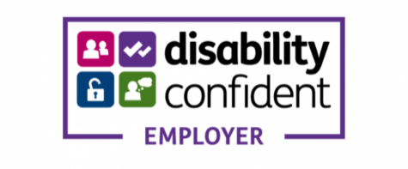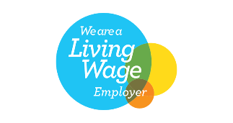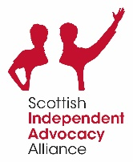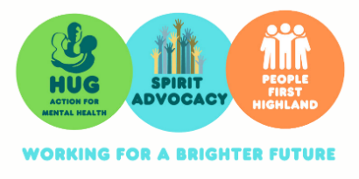**Spirit Advocacy is Scottish Incorporated Charitable Organisation SC042513**