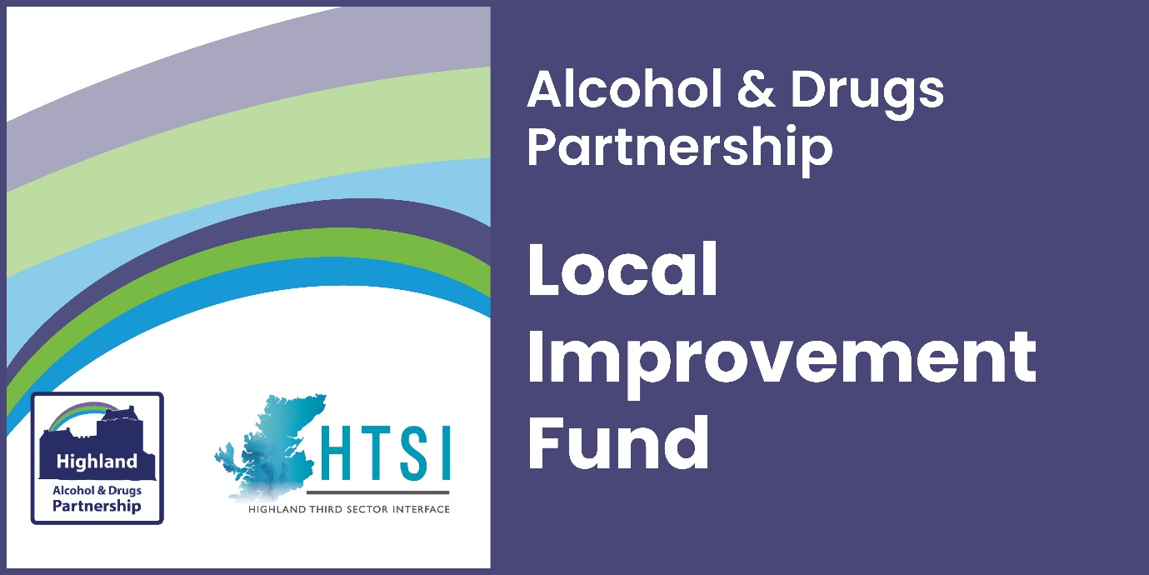

Frequently Asked Questions

We will keep this up to date as further queries come in.
How do I apply?
You can submit an expression of interest through the HTSI website portal. We expect that most expressions of interest will be completed online. Where organisations encounter any barriers, we can accept expressions of interest via an electronic copy using Word, or paper copy. Please contact us if you would like to request an alternative version.
You can only submit a more detailed application for this fund, if invited to do so, after we’ve received and assessed your expression of interest.
When can I apply and when will a decision be made?
Expressions of interest should be submitted by 27 July 2023 at 12.00 midday. If you meet the essential criteria, then we will be in touch by the end of July to invite you to submit a more detailed application by the 23 August. We will also let you know if you are not invited to apply.
Essential criteria:
- In line with Highland ADP strategy
- Previous experience operating or delivering services in the area
- Previous experience working with vulnerable people
- People-led proposals (lived experience shaping the project)
- Clear outcomes for the participants (which will be measured)
What should I do if I have not heard from you, by the end of July?
If you submitted an EOI by the closing date and have not heard back from us, we recommend you contact us without delay in case our correspondence was undeliverable. Email funding@highlandtsi.org.uk or call 07826 821 545.
How can I obtain a copy of my expression of interest?
You should receive an automatic response from Jotform (the online portal) with a copy of your expression of interest - this is sent to the email address listed in your submission under ‘main contact’. If you don’t receive this, please check in your junk/spam folder, then contact us for a copy.
What is a unique identifier?
Jotform will issue a unique ID number for each expression of interest that is submitted. If you are then invited to apply, you will be asked to enter this ID number on the application form, which will automatically prefill the form with the answers you provided previously. You should not change any of the answers from your expression of interest but move directly to the first question on the application form.
What can I apply for?
The range of items you can include in your proposal are wide-ranging, so long as you can provide evidence that endorses the need as well as the proposed activity. You must explain the relevancy and anticipated impacts and outcomes from your activity.
What may I not apply for?
There are only a few activities that will not be considered:
- Contingency costs, loans, endowments or interest
- Electricity generation and feed-in tariff payment
- Political or religious campaigning
- Profit-making/fundraising activities
- VAT you could reclaim
- Statutory activities
- Overseas travel
- Alcohol
Who can apply?
Any constituted third sector organisation who has access to their own bank account and can demonstrate their ability to competently deliver the proposed activities, outlined in their application.
In addition, you (or one of your partners in a collaborative bid) must have experience operating or delivering services in the Highlands and working with vulnerable groups.
Previous Local Improvement Fund grantees are able to apply, unless you are requesting funds to continue delivering the same activity as before. The activity in this round of funding must be a significant development, expansion or departure from what was funded before. For example, we may consider requests to deliver a previously successful activity to a totally new target group or community. But you should be able to evidence the outcomes from this project to demonstrate the success.
How much can I apply for?
The maximum grant in this round of Local Improvement Funding is £50,000 per organisation or collaborative bid and this can be spent anytime between October 2023 and March 2025. You can apply for any amount up to £50,000 but your request should be driven by the actual cost of what you want to pilot or deliver, rather than designing activity to fit the budget.
When does the activity have to start?
The funding should be awarded by September 2023, and we would like to see activity begin in October 2023. However, if for any reason you need to delay starting your activity that is fine, as long as it’s not expected to run beyond March 2025. We aim to be gathering in reports on your activity by March 2025 at the latest, or as soon as you wrap up activities.
When does the funding have to be spent by?
The end date is no later than 31 March 2025. Your activity can run for anything up to eighteen months, but you must state in your application your proposed timescale.
Am I expected to work in partnership?
The short answer is yes.
You don’t have to submit a collaborative bid, but you will be asked how you are working with groups and other organisations in your area, and you need to make sure you can answer that.
Additionally, it is important that you can describe how people who will benefit from your proposed activities have been involved in designing the activity. We are keen to avoid unnecessary duplication and would encourage you to make sure you explain how you are linking into similar services to provide assurance that this is adding value and not duplicating an existing service.
What reporting and evaluation expectations are there?
All projects will have to complete a minimum of a final evaluation report and equality monitoring. The final report will expect you to confirm the actual spend and evidence of change against the outcomes that you outlined in your application.
If your outcomes include work that aims to improve the health and mental wellbeing of participants, we ask that you consider using a wellbeing indicator (such as WEMWBS) and a physical health question alongside this. Please contact us for more information and resources you can use to measure health and wellbeing.
The level of detail should be proportionate to the funding received, meaning the larger your grant sum, we would anticipate a higher level of activity and consequently a higher level of detail.
The lead partner will be responsible for submitting reports as requested. You should share the reporting schedule with your partner organisations, to ensure that they can provide the relevant data to contribute to the reports. Failure to provide your report on time may influence future funding decisions.
How do you expect us to involve people with living/lived experience?
The local strategy - Rights, Respect, Recovery - acknowledges that people with personal experience of drug and alcohol problems should be meaningfully involved in service and policy development.
It is important that you describe the pro-active methods you employ to involve people. You may have people with lived experience of drug and alcohol problems among your staff team, volunteers, board of trustees and service participants, who will help to provide you with their perspective on service development. However, we will also be looking for evidence of recent communication with community groups and individuals with living experience, people who understand the current issues and views of those who live and work in the area and are affected by substance misuse issues.
It's particularly valuable if you can gather views from those who are not involved in existing third sector support services or action groups, to understand what they perceive to be the gaps and what would encourage them to get involved? You can do this at public meetings, consultation events, focus groups or using surveys (digitally or in person).
How long will the second stage application take?
The second stage application will take longer to deliberate, as decisions will be made by a panel using a scoring system, to determine who meets the second stage criteria.
Applicants have between end July and 23 August to complete the final application form. The panel will then select the highest quality applications and award the grant monies accordingly.
Second Stage Criteria:
- demonstrates how the project delivers in line with local strategies and expected outcomes
- demonstrates the need for the project through recent consultation with the community
- demonstrates your ability to deliver change in the community through existing connections/working relationships
- demonstrates an understanding of how community participation can contribute to more successful delivery of the project
- shows how the safeguarding of vulnerable people has been implemented into project planning and delivery
- demonstrates how you will measure change in individuals and/or the community, proportionate to the size of the grant you are requesting
- demonstrates how you will measure inclusion of people with protected characteristics, reflecting the community you serve
- shows that consideration of fair work practices has been included in the project proposal, including how to overcome current recruitment challenges, with indicative costs
- demonstrates that environmental impact is considered and plans to mitigate it have been described

What type of projects will the panel be looking for?
The proposals should address the following priorities aligned with the Highland ADP Stratagey.
- Reduce the number of people developing problematic use of substances by tackling the root causes of alcohol and drug-related harm at a local level.
- Reduce the number of people developing alcohol and drug-related harm by developing prevention and early intervention programmes through whole family approaches and family inclusive practice.
- Reduce harmful behaviours by offering targeted local support to individuals, families and groups.
- Improve access to support and treatment for individuals affected by alcohol and drug-related harm.
- Reduce stigma and improve reach and engagement with people affected by drug and alcohol problems, by promoting more inclusive, supportive communities.
Who is on the funding panel?
The panel is made up of members of Highland Alcohol & Drugs Partnership, people with living/lived experience and other people with first-hand experience of the relevant issues in Highland, including colleagues from third sector.
When will the panel be meeting?
We are aiming to have a panel meeting towards the end August.
When will a decision be made?
We aim to have awarded the grants and notified all applicants of the decision by September 2023.
Once a decision is made, when will the grant be paid?
If your application is successful, you will be asked to complete a funding agreement. The grant will be paid within two weeks of HTSI receiving the completed funding agreement from you.
What if I submit an application by the closing date and receive no response?
We recommend that you contact us without delay if you have not heard from us by beginning of September. Please call 01349 864289.

