Are you interested in being
A Member of the Board of the Puffin Hydrotherapy Pool?
Background
- The Pool is located adjacent to the Ross Memorial Hospital in Dingwall and the Charity Shop is in Dingwall town centre
- The Pool is a registered Scottish charity and a company limited by guarantee.
- Most of the running cost of the pool is met through charitable donations. A small annual grant is received from the Highland Council and NHS Highland have a contract with the pool for use by the Rheumatology patients. As welcome as these are, they are far from meeting the total costs of the pool and its staffing.
- Finance is a major challenge.
- The pool is open to all who feel they could benefit from hydrotherapy treatment and is supported by specialist physiotherapists to assess and guide treatment where required. No medical referral is required, but you many be assessed as to how best the pool and staff can support you.
- The pool is much loved and supported by local communities and classes such as mother and baby and swimming lessons.
- The shop is run by a manager and our wonderful volunteers
- The pool is staffed by our fabulous Highlife Highland staff under contract to the Board
Summary of role
- As a Board Member you are responsible for the strategic management of the running of the Puffin Hydrotherapy Pool and the supporting Charity Shop, working collaboratively with existing Board Members and the staff.

- We are looking for Board members who feel passionate about maintaining and growing the hydrotherapy service for our communities and in particular we seek skills and experience in finance and retail. If you have been or are a current user of the pool and would like to be more involved, then now is the time to come forward. Board Members serve in a voluntary capacity.

- You don’t need to have previous experience as a Board Member / Trustee to join our Board as we are a friendly organisation who offer training and support as required and on an ongoing basis.

What might you be doing?
- Attend Board Meetings regularly (approximately 4 each year)
- Take an active part in the discussions at the meetings
- Take an interest in the work of the pool and the shop
- You might have a specific skill you can bring to the board eg financial management, retail, user of the pool.
- Help set policies and guide the strategic management of the pool and shop
- Provide enthusiastic support for volunteers and staff

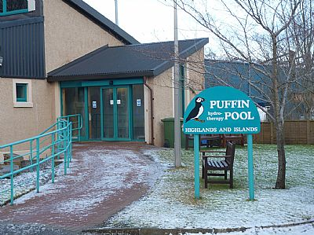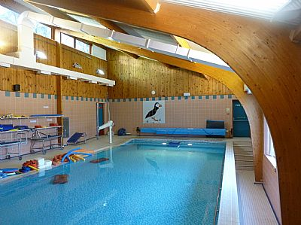
Does this sound like you?
- Committed to the provision of Hydrotherapy treatment in the Highlands
- Able to think creatively and exercise good, independent judgement
- Work effectively as a member of a team
- Happy to help with identifying and raising funds to support the pool
- Able to understand and accept the responsibility of being a trustee and employer
- May have a specific organisational skill.

Want to know more about us? Interested in joining as Volunteer or Board member?
Contact either
- Hugh Mackay (Chair) 07944 20185, hugh650@btinternet.com
Or
- Linda Kirkland (Secretary) 07999 584955 linda.kirkland@btinternet.com

