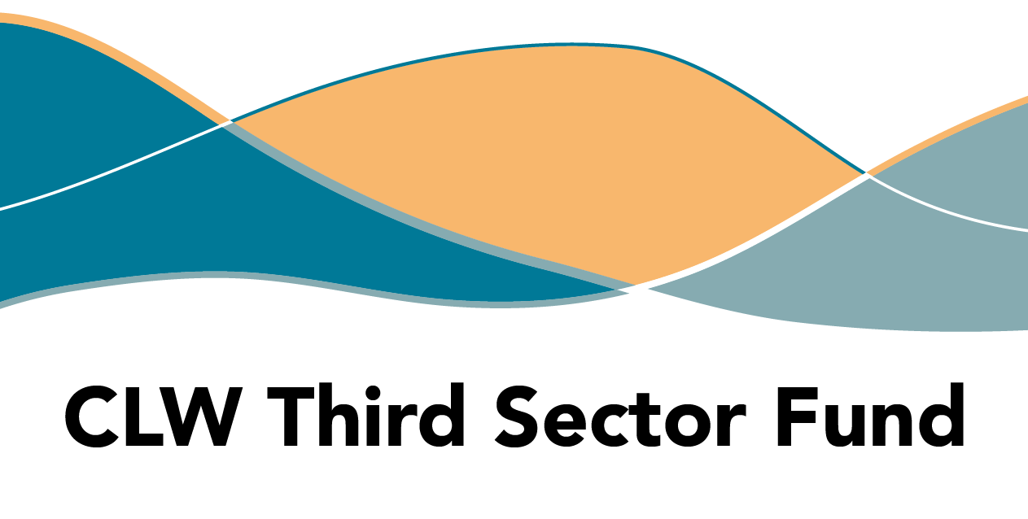

**FAQs**

**Frequently Asked Questions**

We will keep this up to date as we receive further enquiries.

**How do I apply?**

You can submit an application through the **HTSI online portal**. The application button can be found on our dedicated webpage after the opening date 21 April 2025.

JotForm is the online platform we use for applications and is set to issue an auto-response when you submit an application, which includes an attachment - a PDF of your application form. This email from JotForm contains a hyperlink to edit your submission (located at the end of the message).

This link allows you to return to the form for ongoing completion or edit your submission. You should save this email for future reference. If you can’t find the email, this could be because:

* It has gone to your Junk/Spam folder,
* The email you’ve added contains a typo and is undeliverable.

Please contact us on [**enquiry@highlandtsi.org.uk**](mailto:enquiry@highlandtsi.org.uk) if you experience technical difficulties.

**What is social prescribing?**

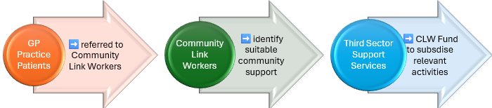Social prescribing focuses on improving health outcomes for people experiencing stressors in their lives due to social issues. GPs refer patients to Community Link Workers, who take a person-centred approach to each referral. This fund aims to offer grants to third sector groups so they can accept (increased) referrals from CLWs for community-based activities.

These activities may include support with mental or physical health, support for unpaid carers, housing support, advocacy, 1-1 support or group support.

**When can I apply and when will a decision be made?**

Applications should be submitted by **Friday** **6 June at 12.00 midday**. We have arranged a funding panel for 30 June, after which you will be notified of their decision. We will also let you know if your application is not successful.

**How will I know my application was received?**

When you submit your application in the online portal JotForm, a thank you message will pop up on your screen to let you know it was submitted. In addition, an email is automatically generated by the online platform, issued to the primary email in the form with a copy of your application.

**How can I obtain a copy of my application?**

You should receive an automatic response from JotForm with a copy of your application - this is sent to the email address listed in your submission under ‘main contact email’. If you don’t receive this, please check in your junk/spam folder, before you contact us asking for a copy.

**Will you accept late submissions under any circumstances?**

We will not accept late submissions, unless there was a technical fault with the online application portal, ie. JotForm. However, we would expect applicants to allow sufficient time to deal with any technical issues.

**What can I apply for?**

The funded services should support social prescribing by enabling increased capacity to accept referrals from community link workers or create new activities for referral.

Services must be primarily aimed at adults (over 18 years) and could potentially cover a wide range of social issues that can impact on health and wellbeing.

The range of items you can include in your proposal are wide-ranging, so long as you can provide evidence that endorses the need as well as the proposed activity. You must explain the relevancy and anticipated impacts and outputs from your activity.

**What may I not apply for?**

There are a few activities that will not be considered:

* Contingency costs, loans, endowments or interest
* Electricity generation and feed-in tariff payment
* Political or religious campaigning
* Profit-making/fundraising activities
* VAT you could reclaim
* Statutory activities
* Overseas travel
* Alcohol

**What type of projects will the panel be looking for?**

Your proposal should fit with the aims of social prescribing, which is focused on alleviating a range of social issues that impact on peoples’ mental and physical health.

The panel will be looking for proposals that demonstrate a viable, sustainable response to needs identified from community engagement, alongside evidence of community involvement in delivery of the project.

Within these parameters, there are no specific types of service excluded from this fund, but applicants should ensure that any proposed service does not overlap or duplicate existing resources, is designed in collaboration with related community groups/services, and links with existing networks to ensure best value.

**What are GP Clusters?**

GP clusters are typically groups of between five to eight GP practices in a close geographical location. The purpose of clusters is to:

* encourage quality improvement activity among GPs
* contribute to the oversight/development of local healthcare

This fund is aimed at eight specific GP Clusters which already exist in Highland. Please see details online and in the application guidance.

**What if our proposed service does not cover the whole cluster area?**

The aim is to provide activity that serves a patient population within one or more GP clusters, which have been designated the priorities for this funding. You are not required to cover the whole GP Cluster area.

**What if our service may cover more than one cluster area?**

The aim is to provide activity that serves a patient population within one or more GP clusters, which have been designated the priorities for this funding. You may select more than one cluster within the application.

**Who can apply?**

Any constituted third sector organisation who has access to their own bank account and can demonstrate their ability to competently deliver the proposed activities, outlined in their application.

In addition, you (or one of your partners in a collaborative bid) must have experience operating or delivering services in the Highlands.

Unincorporated organisations may not apply for a grant but can benefit from the funding by collaborating/partnering with an organisation that has the necessary structure and safeguards in place to manage the grant.

**How much can I apply for?**

The maximum grant is £10,000 per proposed project or collaborative bid to be spent during the funding period - July 2025 - March 2027. Your request should be driven by the actual cost of what you want to pilot or deliver, rather than designing activity to fit the budget or timeline of the fund.

**What duration of project would be eligible?**

Your project duration should be dictated by the amount of funding available and the cost of delivering the proposed activity. This could include projects that deliver activity for six months or twenty months. The panel will consider value, sustainability and the potential impact.

**Can an organisation apply for more than one grant?**

Yes, one organisation may apply for more than the maximum amount, if requesting funds for more than one project. However, the funding panel will be seeking to achieve the best value and benefit to communities across the Highland area, so they may choose to avoid awarding multiple funds in one locality.

This will be at the panel's discretion as we cannot predict who will apply, or which localities will benefit from the submitted proposals.

Staff from both health improvement and primary care will be involved in the funding panel, to ensure distribution of monies will meet the desired outcomes.

**When does the activity have to start?**

The activity should begin as soon as you receive payment which we aim to deliver in July 2025.

**When does the funding have to be spent by?**

The funding should be spent by 31 March 2027.

You must state in your application the proposed timescale for your project.

Successful applicants will be required to submit final reports within **two weeks** of the end date for your project.

**Am I expected to work in partnership?**

The short answer is yes.

You don’t have to submit a collaborative bid, but it is expected that you are engaging with groups and other organisations in your area, because there is clear evidence that collaborative working is more effective.

Additionally, it is important that you can describe how people who will benefit from your proposed activities have been involved in designing the activities and how they are delivered. We are keen to avoid unnecessary duplication and would encourage you to make sure you explain how you are linking into similar services to provide assurance that this is adding value and not duplicating an existing service.

**What reporting and evaluation expectations are there?**

All projects will have to complete a final evaluation report as a minimum. Successful applicants will be advised of the reporting parameters and schedule. This usually includes progress reports every six months.

The final report will expect you to confirm the actual spend and evidence of change against the **outcomes** stated in your application, as well as the methods used to measure the difference made.

The level of detail should be proportionate to the funding received, meaning the larger your grant sum, we would anticipate a higher level of activity and consequently a higher level of detail.

In a collaborative bid, the lead partner is responsible for submitting the report. You should share the reporting schedule with partner organisations, to ensure that they can provide the relevant data to contribute to the reports. Failure to provide your report on time generates additional work and may influence future funding decisions.

**Why do projects only have two weeks to submit final reports?**

We expect projects to include continuous data gathering throughout the project, to inform progress and collate evidence of impact. Thus, projects should be able to demonstrate the difference the project made without the need for extra time after projects are delivered. Two weeks after completion should be sufficient time for the evidence to be collated and we provide plenty of notice, so that time can be set aside in your calendar for reporting.

**Who is on the funding panel?**

Staff from Health Improvement, Primary Care, Change Mental Health, and our TSI delivery partners who cover remote and rural localities in Highland.

**When will a decision be made?**

We will make decisions at a panel meeting 30 June, which is three weeks after the closing date. This time is necessary for panel members to assess the proposals. Therefore, we will be able to notify applicants of the decision in the first week of July.

**What should I do if I have not heard from you?**

If you applied by the closing date/time and have not heard back from us by 4 July, we recommend you contact us without delay in case there was a technical issue delivering our emails. Email [funding@highlandtsi.org.uk](mailto:funding@highlandtsi.org.uk) or call 07826 821 545.

**Once a decision is made, when will the grant be paid?**

If your application is successful, you will be asked to complete a funding agreement. The grant will be paid once HTSI receive your signed funding agreement.