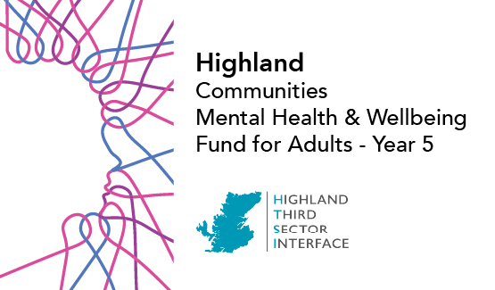

EOI SAMPLE FORM £50,000 or less
Please read through the guidance document carefully before completing this form. Your EOI should be submitted by MIDDAY on Tuesday 30 September.
SAMPLE EOI –SUBMIT APPLICATION ONLINE
- Do you have a bank account registered in your organisation’s name?
Yes
No
- Do you have a Fair Work First policy statement?
Yes
No
We do not have employees
- Have you applied/do you intend to apply to any other TSIs for Communities Mental Health & Wellbeing for Adults funding in 2025-26?*
Yes
No
Not sure

Tell us about your organisation
1. Name of Organisation*
2. Main Contact*
First Name Last Name
3. Job Title/designation*
4. Email Address*
5. Phone Number*

6. Secondary Contact*
First Name Last Name
7. Job Title/designation*
8. Email *
9. Phone Number*

10. Briefly tell us about your organisation and any relevant experience working with vulnerable groups.*
This is not where you describe your project plans0/50

Tell us about your project
11. Name of project and project postcode:*

12. Please tick one of the following types of initiatives which best describes your project:*
- Befriending | - Peer Support
- Counselling | - Therapeutic
- Mentoring | - Financial inclusion/cost
- One to One | - Group Activity
- Equipment | - Food
- Nature | - Social
- Arts and Crafts | - Maintenance/repair
- Sport or physical activity | - Culture

13. Please enter the number of volunteers involved in delivering the project.*
Numerical entries only
14. Please describe the project including its key aims and activities and how this supports mental health and wellbeing. (max. 100 words)*

15. Is your project for the general population (general), open to all but with a focus on particular target groups (targeted) or aimed only at particular target groups (restricted)?*
General / Targeted / Restricted?
16. If your project is targeting specific groups of people, which groups of people are you seeking to reach? (Select no more than three)
- Women (particularly women affected by gender-based violence)
- People with a long-term health condition or disability
- People from a minority ethnic background
- Refugees and those with no recourse to public funds
- People facing socio-economic disadvantage
- People experiencing severe and multiple disadvantage
- People with diagnosed mental illness
- People affected by psychological trauma (including adverse childhood experiences)
- People who have experienced bereavement or loss
- People disadvantaged by geographical location (particularly remote and rural areas)
- People with neurological conditions or learning disabilities, and from neurodiverse communities
- Older people (aged 50 and above)
- Lesbian, Gay, Bisexual, Transgender and Intersex (LGBTI) communities
- Young people aged 16-24
- Other
17. Cost of Living - the following family types are considered to be most at risk of poverty. Please select any (or all) who are highly likely to engage with this project.
- Lone parents
- Families with a disabled family member
- Families with 3+ Children
- Minority ethnic families
- Families where the youngest children are under 1 year old
- Mothers aged less than 25
18. National/Local Priorities - please tick any (or all) of the following priorities your project will contribute to:*
- Suicide prevention
- Social Isolation/loneliness
- Addressing poverty and inequality
- Other (select from Local Priorities List below)
- Unpaid carers
- People with long-term conditions
- Rurally disadvantaged
- Psychological Trauma
19. Please tell us more about the community you're working with and why you intend to implement the proposed development or collaborative project. (max. 200 words)*

20. Please enter details for each partner collaborating with you on this proposal:
 | Name | Description
1
2
3
4
Tell us about your finances
21. Please select the category which describes the income of your organisation:*
- Organisation with income up to £5,000
- Organisation with income up to £10,000
- Organisation with income up to £25,000
- Organisation with income between £25,000 and £100,000
- Organisation with income between £100,000 and £500,000
- Organisation with income between £500,000 and £1 million per annum
- Organisation with income over £1 million per annum
22. Have you received a grant from the Communities Mental Health & Wellbeing Fund from HTSI before?*
Yes / No
23. Is your application for a new project or for a continuation/expansion of an existing project? (Select one)*
- New project
- Existing project (previously funded through the Communities Fund)
- Existing project (New to Communities Fund but funded previously through another funding organisation)
Project Costs
The maximum amount of capital costs we can fund is £5,000.
24. Total project costs (rounded to nearest whole number - no currency symbols or commas).*
 | Yr1 £ | Yr2 £
Combined revenue and capital costs

25. Amount requested (rounded to nearest whole number - no currency symbols or commas).*
 | Yr1 £ | Yr2 £
Amount requested from us:

Tell us more about your plans
26. In which locality do you plan to focus your work?*
- Badenoch & Strathspey
- Caithness
- Easter Ross
- Highland-wide
- Inverness-shire
- Lochaber
- Mid-Ross
- Nairnshire
- Skye & Lochalsh
- Sutherland
- Wester Ross
27. Is there a specific geographic community or neighbourhood you will focus on within the above locality? (20 words max)

28. Please select the date you will start your activity:*
Start Date
Please select the date you will finish your activity:*
End Date
We recommend you have someone check your application for typos and numerical errors before submitting online.*
If you have not competed this form but would like to save your progress, please click the save button.
This will send an email to the main contact with a link to continue your expression of interest.

