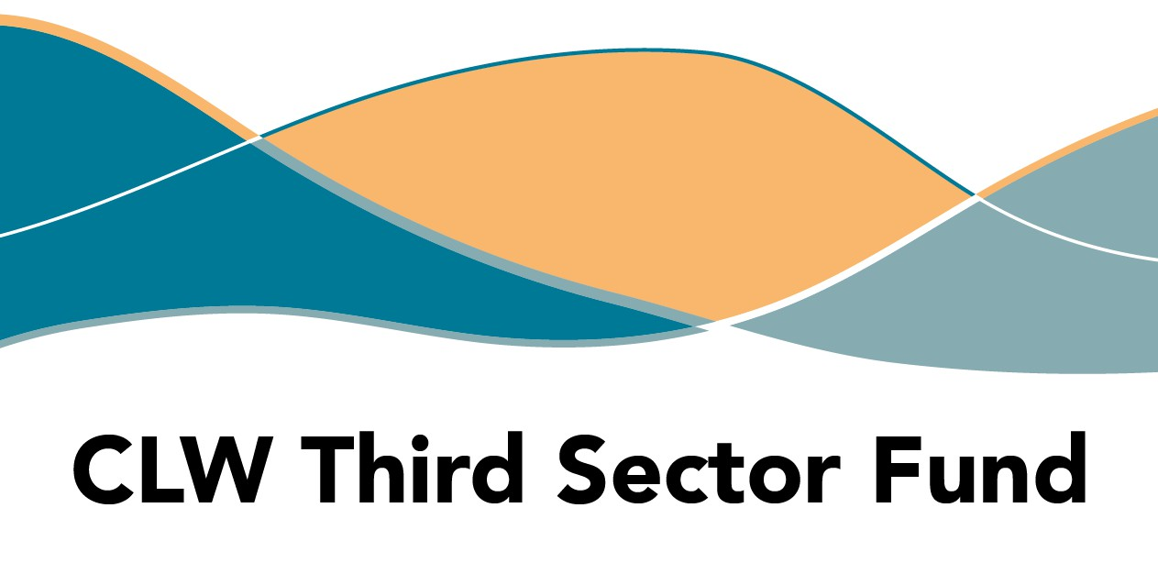
SAMPLE APPLICATION FORM

The content of this form must be copied into Jotform online:
https://form.jotform.com/250582243279359
Remember to add spacing into the form before you submit online. Line breaks will make your application easier to read. You could improve the chance of your application being successful by being clear and concise when describing your proposal.
Deadline to submit your application – Friday 6 June at 12.00 midday.
Do you have a bank account registered in the organisation’s name?*
- Yes
- No
To proceed with an application for this fund, you are expected to have a bank account in the organisation’s name.
Can you confirm your organisation complies with the Fair Work First policy?*
- Yes
- No
Tell us about your organisation
Organisation Name Website

Name of primary contact

Email Phone Number

Name of secondary contact

Email Phone

Select your organisation’s legal structure from the options:
- Scottish Charitable Incorporated Organisations (SCIO)
- Companies Limited by Guarantee
- Trusts
- Not-for-profit company, asset locked company, or Community Interest Company
- Cooperative and Community Benefit Societies
- Community councils

Q1. Tell us about your organisation: you should include your experience operating in Highland.* (100 words)

Q2. Provide details about your proposed project.*

250
Q3. What difference will this make for people who participate in the project?*
Describe the change(s) you hope will be observed:
Outcome 1
Outcome 2
Outcome 3
Outcome 4
10 words each
Q4. What methods will be used to measure the changes described in Q3?*

100
Q5. How will your proposed activity create or increase capacity for community link workers to make social prescribing referrals?*

200
Q6. In which GP Cluster do you plan to focus your work?*
- Cluster 1 Is there a specific village or community you
- Cluster 4 intend to focus on?

- Cluster 6
- Cluster 7
- Cluster 8
- Cluster 10
- Cluster 11
- Cluster 12
Q7. How did you identify a need for this activity/service?*

200
Q8. Start/End Dates*
Q9. Projected REVENUE expenditure for the project:*
 | Revenue item heading | £
1
2
3
4
5
Total Revenue
Q10. Projected CAPITAL expenditure for the project:*
 | Capital item heading | £
1
2
3
4
5
Total Capital
Q11. Match funding
 | Amount | Confirmed | Org Name
1 |  | Yes/No
2 |  | Yes/No
3 |  | Yes/No
4 |  | Yes/No
Q12. In-kind support

Q13. Total project costs* Q14. Amount requested*

Hint: The amount requested plus match funding should equal the total project costs.
Q15. Please provide income/expenditure details for the period ending 31 March 2024 for your whole organisation, not the department related to this application.*
£
Income
Expenditure
Surplus/Deficit at year end
Total savings/reserves at year end
Please attach a copy of your latest independently verified accounts, as required by your governance structure.

Browse Files
Drag and drop files here


Please sign and submit form *

Submit the application by Friday 6 June at 12.00 midday via the online portal.
https://form.jotform.com/250582243279359

