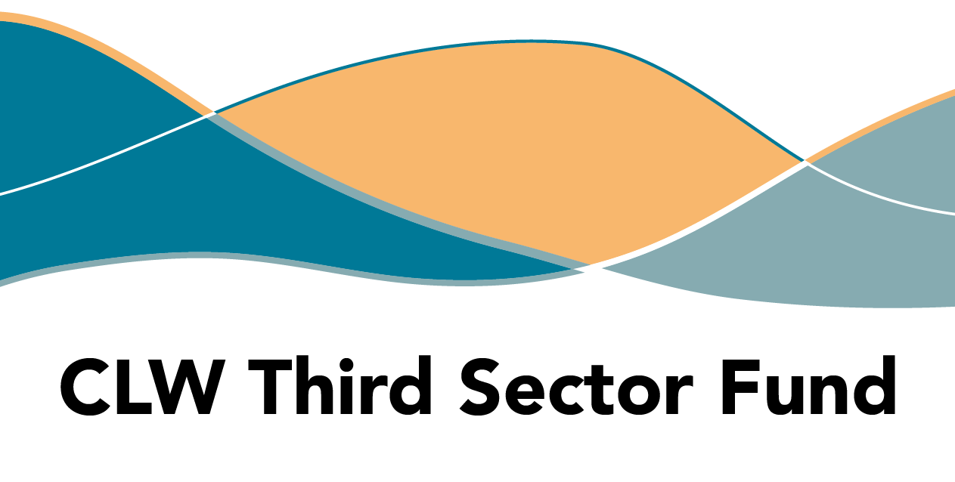

**APPLICATION**

**GUIDANCE**

Contents:

Purpose 2

Process 2

Eligibility Check 3

Questions 4

Financial Breakdown 7

Submission 8

**Purpose**

Courtesy of NHS Highland, third sector organisations are invited to apply for up to £10,000 to be spent between 2025 and 2027, to increase capacity to accept referrals from Community Link Workers or create new activities for referral.

Social prescribing focuses on improving health outcomes for people experiencing stressors in their lives due to social issues. GPs refer patients to Community Link Workers, who take a person-centred approach to each referral.

​​This fund is available, courtesy of NHS Highland, to increase support and address gaps in services for social prescribing in remote and rural GP Cluster areas.

What will HTSI fund?

We invite applications of up to £10,000 maximum, to operate community-led local projects aimed at addressing gaps in service in the following areas:

Projects may be short-term or continue delivery up to end March 2027. However, we recommend providing some space for flexibility in your project dates. This permits us to approve an extension of activities where necessary, or would provide additional time to collate data for your final report.

Process

You are invited to submit a funding proposal through the [Highland Third Sector Interface JotForm](https://form.jotform.com/221991630805356) <https://form.jotform.com/250582243279359>.

Applications must be submitted by **Friday 6 June at 12.00 midday** and will be assessed against the criteria by a panel of health and social care professionals from both public and third sector, including people with lived experience.

We recommend that you save your application, as soon as you have entered your contact details, to confirm that you can access the form to review your answers. If you encounter technical issues with JotForm, please email [**enquiry@highlandtsi.org.uk**](mailto:enquiry@highlandtsi.org.uk).

Assessment Criteria

Decisions will be based on how well your application demonstrates that you meet the following criteria:

* Focused on improving services in the selected GP Clusters
* Previous experience operating in the Highlands
* Previous experience working with vulnerable people
* Evidence of community engagement which identified the need for your project
* Evidence of community involvement in shaping project delivery
* Clear outcomes for individual participants including the methods you’ll use to measure the difference

​Before you complete the questions, review your application against the criteria listed above. Are there potential areas for improvement to demonstrate your understanding of the key criteria?

Try not to make assumptions about prior knowledge on the part of panel members; include everything you think is relevant to your proposed activity.

Be clear, compelling and concise - making effective use of the limited space provided. There are online articles which include guidance on how to limit the number of words used to describe your project.

This is the only application stage, and we have provided a relatively long time for the application to be submitted, so please leave sufficient time for a third party to check your answers for accuracy, clarity and proofreading. Once you submit your application, proposals that do not provide enough explanation or clarity will be rejected by the panel.

Eligibility check

**Bank account registered in the organisation's name:**

All groups applying must have a bank account and accounts from the previous financial year, which provides evidence of their ability to competently deliver their plans and account for the spend provided through a grant.

**Fair Work First**

All applicants are required to provide a statement describing how the organisation is committed to advancing the Fair Work First Policy including the ‘Real Living Wage’ and ‘Effective Workers Voice’ criteria. You should post this online.

This statement is applicable to all groups and organisations even if you do not directly employ staff or only work with volunteers. Please refer to the [Scottish Government's Fair Work First Guidance](https://www.gov.scot/publications/fair-work-first-guidance-3/).

Questions

If a question is marked with an asterisk, you are required to complete it.

**Website -** please provide the URL for your preferred digital communication platform if you have one. If you do not have any online communication platform you may leave this blank.

**Contact details** – we ask for primary and secondary contact because there may be personnel changes during the project and reporting period, so we must be able to reach someone within the organisation beyond the project duration.

**Select your organisation’s legal structure from the options:**

* Scottish Charitable Incorporated Organisations (SCIO)
* Companies Limited by Guarantee
* Trusts
* Not-for-profit company, asset locked company, or Community Interest Company
* Cooperative and Community Benefit Societies
* Community councils

Unincorporated Associations (UAs) will not be eligible to apply for a grant, but you may collaborate with another organisation which has the infrastructure and safeguards to help minimise risk. In this scenario, the other organisation would be the lead applicant, and the UA would deliver the project in partnership.

**Q1. Tell us about your organisation: you should include your experience operating in Highland.* (100 words)**

Provide a brief statement about your organisation, which includes experience operating or delivering services in the Highland area, understanding local challenges and needs. If relevant, please include your organisation’s safeguarding measures for staff, volunteers and participants.

**Q2. Provide details about your proposed project.* (250 words)**

You should include:

* type of activities
* outputs, e.g. number of participants, sessions, staffing, etc.
* relevant timing, e.g. schedule of activities, duration of each session

Please use formatting to provide a clear, compelling description of your project, including the topics requested above as a minimum.

**Q3. What difference will this make for people who participate in the project?\***

We provide space for a maximum of four outcomes, which should describe changes which can realistically be achieved by individuals due to their participation in your activity. Use concise, active language that describes the specific changes you anticipate. These might include e.g. improvements in wellbeing, or reductions in harm. Be specific, precise and pithy!

Ensure your outcomes are measurable. For example, if your project is about employability, your outcome could be ‘improving skills and confidence’ in individuals. If you project is about social connections, your outcome may be ‘reducing social isolation or loneliness’. The outcome wording should not include how this improvement will come about, as this should be described in Q2. As a guide, each outcome should be less than 10 words.

Before you decide your outcomes, consider how these would be measured and what would success look like.

**Q4. What methods will be used to measure the changes described in Q3?* (100 words)**

How will you identify when changes occur? Consider the most likely indicators (or signs) of the changes you anticipate and how will you capture them, e.g. improvement in confidence, or reduction in harm. This might involve designing a survey that asks people about these changes, or staff may record their observations. You might choose to capture individual levels of understanding and/or perspective before and after your project and compare results. Please note that anonymous surveys will not help you compare individual results over time, you’ll need to assign unique identifiers and store records securely.

**Q5. How will your proposed activity create or increase capacity for community link workers to make social prescribing referrals?* (200 words)**

Describe how your proposed service/activity will engage with community link workers to ensure the referral pathway is accessible and effective. If you already deliver an activity which tackles health inequalities, describe how you will ensure this grant would enhance your capacity to accept referrals from community link workers.

**Q6. In which GP Cluster do you plan to focus your work?\***

* Cluster 1 Is there a specific village or community you
* Cluster 4 intend to focus on?
* Cluster 6
* Cluster 7
* Cluster 8
* Cluster 10
* Cluster 11
* Cluster 12

You may select all that apply – please refer to the web page for the full list of cluster areas/GP practices. Please remember that applications will be assessed against evidence of need and viability, so it is important you can evidence local knowledge.

**Q7. How did you identify a need for this activity/service?* (200 words)**

Please describe how you have engaged with the selected community (geographic or thematic) to identify or analyse their needs and indicate whether this need is reflected in any local plans.

Please include when this engagement was carried out and estimated number of people engaged, along with any particular developments that evolved from this engagement.

**Q8. Start/End Dates\***

Tell us when you plan to begin and end your project, using the date picker. Activity must not start until payments reach successful applicants.

Please refer to the funding timeline before selecting a date to begin your project. The deadline for application is Friday 6 June and we need a few weeks for the funding panel to assess applications and we cannot issue grant payments until funding agreements have been returned. The final deadline for spending the grant is 31 March 2027.

Your project costs and the maximum amount you may request, will dictate how long you may run the funded project for. There is no minimum project duration to qualify for funding, but the panel will of course assess each proposal for viability and value for money.

Financial Breakdown

Please provide a breakdown of the total project costs even if they would not be funded from the amount requested from this fund. You should not attempt to itemise each individual cost. Try to group items together in cost headings, such as staff costs or event costs.

Only type in the white cells of the table. Remove any currency symbols, punctuation, text from the figures and round up to whole numbers. In the final row, you must calculate the total of your grouped items and add to the table.

**Q9. Projected REVENUE expenditure for the project:\***

Revenue costs are usually associated with daily running costs, such as staffing or regular overheads like room hire, food supplies, tutor hire, etc. This may include, but is not restricted to the following:

* Staff costs (including pensions and employers’ costs)
* Professional fees/Insurances
* Room hire
* Travel costs
* Volunteer expenses

**Q10. Projected CAPITAL expenditure for the project:\***

Capital costs refer to the funds used to acquire, upgrade, and maintain physical assets such as buildings and equipment necessary for the project. Examples of capital expenditure include construction of facilities, major renovations, and procurement of machinery or technology systems. If you are unsure whether project costs are capital or revenue, please contact us to discuss.

**Q11. Match funding (please enter details if applicable)**

If you have match funding, please provide details of the amount, the origin and select yes or no to indicate whether it has been confirmed at the time of this application. Please skip this question if it is not applicable.

**The amount requested plus match funding should equal the total project costs.**

**Q12. In-kind support**

You may confirm details of ‘in kind’ support that will contribute towards this project. For example, volunteer time, a donation of land or services, loan of equipment, free office space etc. The total value of ‘in-kind’ contributions should not form part of the project budget or match funding, but it may strengthen the application to show that this is included. You may also skip this section.

**Q13. Total project costs* -** Confirm the total project costs, which should be the combined revenue and capital costs provided above.

**Q14. Amount requested* –** Confirm the amount requested from this fund (maximum £10,000)

**Q15. Please provide income/expenditure details for the period ending 31 March 2024** for your whole organisation, not the department related to this application.* Figures should be rounded up to the nearest whole number, with no currency symbols or text.

Please provide information for the financial year (12 months) ending in March 2024, if possible. Ordinarily, this would be the same period as your latest verified accounts cover, but it's not essential if this is not possible. If your organisation's accounts cover a different 12-month period, please complete the figures for that period, confirm the dates and explain.

This information is usually accessible through your organisation’s balance sheet, but you may need assistance accessing this. Please make sure you build in enough time to access this from the person who handles your finances, especially if this is external to the organisation. Failure to include this may result in your application not being assessed.

We have provided a free text box to provide any explanation required on your accounts. They may cover a different period of time, a previous financial year or contain apparent anomalies you need to explain to the panel.

**Upload accounts** – please attach a copy of your latest independently verified accounts**,** as required by your governance structure.

Sign and Submit

Submit the application by **Friday 6 June at 12.00 midday** via the online portal.

<https://form.jotform.com/250582243279359>

Funding will be provided, within two weeks of successful applicants returning a signed funding agreement, when requested.